|  |
| --- |
| **ESTIMATE THE CROP YEILD USING**  **DATA ANALYTICS**  **PROJECT REPORT**  By,  SHREEDHAR D  SANJEEVI N  SATHISH KUMAR C  RAJALINGAM |

|  |
| --- |
| **ABSTRACT:**    Agrarian sector in India is facing rigorous problem to maximize the crop productivity. More than 60 percent of the crop still depends on monsoon rainfall. Recent developments in Information Technology for agriculture field has become an interesting research area to predict the crop yield. The problem of yield prediction is a major problem that remains to be solved based on available data. Data Mining techniques are the better choices for this purpose. Different Data Mining techniques are used and evaluated in agriculture for estimating the future year's crop production. This paper presents a brief analysis of crop yield prediction using Multiple Linear Regression (MLR) technique and Density based clustering technique for the selected region i.e. East Godavari district of Andhra Pradesh in  India. |

|  |  |  |  |  |  |  |  |  |  |  |  |  |  |  |  |  |  |  |  |  |  |  |  |  |  |  |  |  |  |  |  |  |  |  |  |  |  |  |  |  |  |  |  |  |  |  |  |  |  |  |  |  |  |  |  |  |  |  |  |  |  |  |  |  |  |  |  |  |  |  |  |  |  |  |  |  |  |  |  |  |  |  |  |  |  |  |  |  |  |  |  |  |  |  |  |  |  |  |  |  |  |  |  |  |  |  |  |  |  |  |  |  |  |  |  |  |  |  |  |  |  |  |  |  |  |  |  |  |  |  |  |
| --- | --- | --- | --- | --- | --- | --- | --- | --- | --- | --- | --- | --- | --- | --- | --- | --- | --- | --- | --- | --- | --- | --- | --- | --- | --- | --- | --- | --- | --- | --- | --- | --- | --- | --- | --- | --- | --- | --- | --- | --- | --- | --- | --- | --- | --- | --- | --- | --- | --- | --- | --- | --- | --- | --- | --- | --- | --- | --- | --- | --- | --- | --- | --- | --- | --- | --- | --- | --- | --- | --- | --- | --- | --- | --- | --- | --- | --- | --- | --- | --- | --- | --- | --- | --- | --- | --- | --- | --- | --- | --- | --- | --- | --- | --- | --- | --- | --- | --- | --- | --- | --- | --- | --- | --- | --- | --- | --- | --- | --- | --- | --- | --- | --- | --- | --- | --- | --- | --- | --- | --- | --- | --- | --- | --- | --- | --- | --- | --- | --- | --- | --- |
| **TABLE OF CONTENT**     |  |  |  |  |  | | --- | --- | --- | --- | --- | | **S.NO** | **CONTENT** | | | **PAGE NO** | | **1.** | **INTRODUCTION** | | | **5** | | **1.1** | **Project Overview** | | | **5** | | **1.2** | **Purpose** | | | **5** | | **2.** |  | **LITRATURE SURVEY** |  | **6** | |  | | **2.1** | **Existing problem** | | | **6** | | **2.2** | **References** | | | **7** | | **2.3** | **Problem Statement** | | | **9** | | **3.** | **IDEATION & PROPOSED SOLUTION** | | | **11** | | **3.1** | **Empathy Map Canvas** | | | **11** | | **3.2** | **Ideation & Brainstorming** | | | **11** | | **3.3** | **Proposed Solution** | | | **14** | | **3.4** | **Problem Solution** | | | **18** | | **4.** | **REQUIREMENT ANALYSIS** | | | **21** | | **4.1** | **Functional Requirements** | | | **21** | | **4.2** | **Non-Functional Requirements** | | | **22** | | **5.** | **PROJECT DESIGN** | | | **23** | | **5.1** | **Data Flow Diagram** | | | **23** | | **5.2** | **Solution & Technical Architecture** | | | **24** | | **5.3** | **User Stories** | | | **28** | | **6.** | **PROJECT PLANNING & SCHEDULING** | | | **32** | | **6.1** | **Sprint Planning & Estimation** | | | **32** | | **6.2** | **Sprint Delivery Schedule** | | | **33** | | **6.3** | **Reports from JIRA** | | | **35** | | **7.** | **CODING & SOLUTIONING** | | | **37** | | **7.1** | **Feature 1** | | | **37** | |

|  |  |  |  |  |  |  |  |  |  |  |  |  |  |  |  |  |  |  |  |  |  |  |  |  |
| --- | --- | --- | --- | --- | --- | --- | --- | --- | --- | --- | --- | --- | --- | --- | --- | --- | --- | --- | --- | --- | --- | --- | --- | --- |
| |  |  |  | | --- | --- | --- | | **7.2** | **Feature 2** | **43** | | **8.** | **TESTING** | **47** | | **8.1** | **Test cases** | **47** | | **9.** | **RESULT** | **51** | | **9.1** | **Performance Metrics** | **51** | | **10.** | **ADVANTAGES & DISADVANTAGES** | **53** | | **11.** | **CONCLUSION** | **54** | | **12.** | **FUTURE SCOPE** | **55** | |

**1.INTRODUCTION:**

**1.1 PROJECT OVERVIEW:**

The data used for this paper are obtained for the years from 1955 to 2009 for East Godavari district of Andhra Pradesh in India. The preliminary data collection is carried out for all the districts of Andhra Pradesh in India. Each area in this collection is identified by the respective longitude and latitude of the region. The evaluation is considered for only East Godavari district of Andhra Pradesh in India. The data are taken in eight input variables. The variables are 'Year', 'Rainfall', 'Area of Sowing', 'Yield', 'Fertilizers' (Nitrogen, Phosphorous and Potassium) and 'Production'. The attribute 'Year' specifies the year in which the data are available in Hectares. 'Rainfall' attribute specifies the average rainfall in the specified year in Centimetres. 'Area of Sowing' attribute specifies the total area sowed in the specified year for that region in Hectares. 'Yield' specifies in Kilogram per hectare. 'Production' attribute specifies the production of crop in the specified year in Metric Tons. 'Fertilizers' specify in Tons in the specified year.

**1.2 PURPOSE:**

In [agriculture,](https://en.wikipedia.org/wiki/Agriculture) the yield is a measurement of the amount of a [crop](https://en.wikipedia.org/wiki/Crop) grown, or product such as wool, meat or milk produced, per unit area of land. The seed ratio is another way of calculating yields.

Innovations, such as the use of [fertilizer,](https://en.wikipedia.org/wiki/Fertilizer) the creation of better farming tools, new methods of farming and improved [crop varieties](https://en.wikipedia.org/wiki/Cultivar), have improved yields. The higher the yield and more [intensive](https://en.wikipedia.org/wiki/Intensive_farming) use of the farmland, the higher the productivity and profitability of a farm; this increases the wellbeing of farming families. Surplus crops beyond the needs of [subsistence agriculture](https://en.wikipedia.org/wiki/Subsistence_agriculture) can be sold or bartered. The more grain or fodder a farmer can produce, the more draft animals such as [horses](https://en.wikipedia.org/wiki/Horse) and [oxen](https://en.wikipedia.org/wiki/Ox) could be

|  |  |  |  |  |  |  |  |  |  |  |  |  |  |  |  |  |  |  |  |  |  |  |  |  |  |  |  |  |  |  |  |  |  |  |  |  |  |  |  |  |  |  |  |  |  |  |  |  |  |  |  |  |  |  |  |  |  |  |  |  |  |  |  |  |  |  |  |  |  |  |  |  |  |  |  |  |  |  |  |  |  |  |  |  |  |  |  |  |  |  |  |  |  |  |  |  |  |  |  |  |  |  |  |  |  |  |  |  |  |  |  |  |  |  |  |  |  |  |  |  |  |  |  |  |  |  |  |  |  |  |
| --- | --- | --- | --- | --- | --- | --- | --- | --- | --- | --- | --- | --- | --- | --- | --- | --- | --- | --- | --- | --- | --- | --- | --- | --- | --- | --- | --- | --- | --- | --- | --- | --- | --- | --- | --- | --- | --- | --- | --- | --- | --- | --- | --- | --- | --- | --- | --- | --- | --- | --- | --- | --- | --- | --- | --- | --- | --- | --- | --- | --- | --- | --- | --- | --- | --- | --- | --- | --- | --- | --- | --- | --- | --- | --- | --- | --- | --- | --- | --- | --- | --- | --- | --- | --- | --- | --- | --- | --- | --- | --- | --- | --- | --- | --- | --- | --- | --- | --- | --- | --- | --- | --- | --- | --- | --- | --- | --- | --- | --- | --- | --- | --- | --- | --- | --- | --- | --- | --- | --- | --- | --- | --- | --- | --- | --- | --- | --- | --- | --- | --- |
| supported and harnessed for labour and production of [manure.](https://en.wikipedia.org/wiki/Manure) Increased crop yields also means fewer hands are needed on farm, freeing them for industry and [commerce.](https://en.wikipedia.org/wiki/Commerce) This, in turn, led to the formation and growth of cities, which then translated into an increased demand for foodstuffs or other agricultural products.  **2.LITRATURE SURVEY:**  **2.1 EXISTING PROBLEM:**   |  |  |  |  | | --- | --- | --- | --- | | The first and most obvious challenge with taking pictures by | | | | | satellites are clouds. Farmland is, quite deliberately, not in hot dry areas. | | | | | | | Regular rain, and associated clouds, means that simply getting pictures of | | | | | | | | crops can be challenging. In England, for example, it would be almost | | | | | | | impossible to find a day without cloud cover over some of the farmland. | | | | | | For predictions to be effective this has to be conducted on a | | | | | | | national or international scale – i.e predicting the yield of a single farm isn’t | | | | | | | sufficient. The predictions have to over a wide area to be of any value. | | | | | The identification of crops, using satellites orbiting at 800km, is | | | | | | | based on a variety of metrics and observations. The most common one | | | | | | | used is to look for “green” fields. The challenge with this method is that | | | | | | | many areas are green. Grass, forests and other crops – all appear green | | | | | | | | and look very similar to the required crops. For this reason, the challenge is | | | | | | | | to filter out the irrelevant “green” and be left with the relevant – the actual | | | | | | | | crops. | | If all the farmland was a single large continuous farm the analysis | | | | | | | of the crops would be far easier – however, farms tend to be a mixture of | | | | | | | | small farms and large agribusiness varying in size by the owner, the crop | | | | | | | and the economics of the country. Identifying different farms, and what | | | | | | | they are growing at different scales becomes complex and prone to error – | | | | | | | i.e. Farm A, Size B, is growing Crop C in Fields D, E and F and Farm X, is | | | | | | | growing Crop Y in Field Z. These different fields and different crops all | | | | | | | need to be identified and allowed for in the overall calculation. | | | |

|  |  |  |  |  |  |  |  |  |  |  |  |  |  |  |  |  |  |  |  |  |  |  |  |  |  |  |  |  |  |  |  |  |  |  |  |  |  |  |
| --- | --- | --- | --- | --- | --- | --- | --- | --- | --- | --- | --- | --- | --- | --- | --- | --- | --- | --- | --- | --- | --- | --- | --- | --- | --- | --- | --- | --- | --- | --- | --- | --- | --- | --- | --- | --- | --- | --- |
| |  |  |  |  | | --- | --- | --- | --- | | To understand a particular crop, e.g. sugar, it is not enough to just | | | | | differentiate the green fields of farmland from the green fields of woods | | | | and grass. There has to be correct identification of the relevant crop. This is | | | | complicated as some farmers grow multiple crops – i.e there may be crops | | | | | of sugar and cassava, which look similar and can look identical to a | | | | satellite from 800km away. Knowing that a particular farm has 100 | | | | hectares of crops is not useful, you must know if he has 80 hectares of | | | | sugar and 20 hectares of cassava. | | | Finally, once the crop has been identified and the area calculated, | | | | | this only gives the area and not the actual yield. The yields will vary | | | | depending on a variety of factors including weather conditions and the | | | | | health of the plant. |      |  | | --- | | **2.2 REFERENCES:** |  1. Dhivya B H, Manjula R, Siva Bharathi S, Madhumathi R. A Survey on Crop Yield Prediction based on Agricultural   Data, International Journal of Innovative Research in Science, Engineering and Technology. 2017; 6(3).   1. Jharna Majumdar, Sneha Naraseeyappa, Shilpa Ankalaki. Analysis of agriculture data using datamining techniques: application of big data. Journal of Big data. 2017. 2. Majumdar J, Ankalaki S. Comparison of clustering algorithms using quality metrics with invariant features   extracted from plant leaves. International Conference on Computational  Science and Engineering. 2016.   1. D Ramesh, B Vishnu Vardhan. Data Mining Techniques and   Applications to Agricultural Yield Data. International |

|  |
| --- |
| Journal of Advanced Research in Computer and Communication  Engineering. 2013; 2(9).   1. Swarupa Rani. The Impact of Data Analytics in Crop Management based on Weather Conditions. International   Journal of Engineering Technology Science and Research. 2017; 4(5):299308.   1. F K Van Evert, S Fountas, D Jakovetic, V Crnojevic, I Travlos, C Kempenaar. Big Data for weed control and crop   protection. John Wiley & Sons Ltd on behalf of European Weed Research  Society, 2017: 218–233.   1. Wu Fan, Chen Chong, Guo Xiaoling, Yu Hua. Prediction of crop yield using Big Data. 8th International   Symposium on Computational Intelligence and Design. 2015.   1. Dakshayini Patil, M .S, Shirdhonkar. Rice Crop Yield Prediction using Data Mining Techniques: An Overview.   International Journal of Advanced Research in Computer Science and  Software Engineering, 2017; 7(5):427-431.   1. Dhivya B H, Manjula R, Siva Bharathi S, Madhumathi R. A Survey on   Crop Yield Prediction based on Agricultural  Data, International Journal of Innovative Research in Science, Engineering and Technology. 2017; 6(3):4177-4182.   1. Yogesh Gandge, Sandhya. A Study on Various Data Mining   Techniques for Crop Yield Prediction, International  Conference on Electrical, Electronics, Communication, Computer and  Optimization Techniques, IEEE, 2017;420- |

|  |
| --- |
| 423   1. R. Sujatha, P.Isakki Devi. A Study on Crop Yield Forecasting Using   Classification Techniques, IEEE, 2016.   1. V. Sellam and E. Poovammal. Prediction of Crop Yield using   Regression Analysis, Indian Journal of Science and  Technology, 2016; 9(38).   1. Patricio Grassinia, Lenny G.J. van Bussel, Justin Van Warta, Joost   Wolf, Lieven Claessens, d, Haishun Yanga,  Hendrik Boogaarde, Hugo de Groote, Martin K. van Ittersumb, Kenneth G.  Cassman. How good is good enough?  Data requirements for reliable crop yield simulations and yield-gap analysis.  Field Crops Research. 2015; 49–63.   1. David B. Lobell, The use of satellite data for crop yield gap analysis,   Field Crops Research-143, 2013; 56–64.   1. Martin K. van Ittersuma, Kenneth G. Cassmanb, Patricio Grassinib,   Joost Wolfa, Pablo Tittonell, Zvi Hochmand.  Yield gap analysis with local to global relevance-A review. Field Crops  Research – 143, 2013; 4–17  **2.3 PROBLEM STATEMENT:**  Agriculture is important for human survival because it serves the basic need. A well-known fact that the majority of population (≥55%) in India is into agriculture. Due to variations in climatic conditions, there exist bottlenecks for increasing the crop production in India. It has become challenging task to achieve desired targets in Agri based crop yield. Various factors are to be considered which have direct impact on the production, |

|  |
| --- |
| productivity of the crops. Crop yield prediction is one of the important factors in agriculture practices. Farmers need information regarding crop yield before sowing seeds in their fields to achieve enhanced crop yield. The use of technology in agriculture has increased in recent year and data analytics is one such trend that has penetrated into the agriculture field. India is generally an agricultural country. Now a days the most important emerging field in the real world is agriculture and it is the main occupation and backbone of our country. Recent developments in Information Technology for agriculture field has become an interesting research area to predict the crop yield. Crop yield prediction is the methodology to predict the yield of the crops using different parameters like rainfall, temperature, fertilizers, pesticides and other atmospheric conditions and parameters. Data Mining techniques is very popular in the area of agriculture. Data mining techniques are used and evaluated in agriculture for estimating the future years crop production. This paper presents a brief analysis of crop yield prediction using K-Nearest Neighbor(KNN) Algorithm for the selected region that is Mangalore, Kasargod , Hassan, Kodagu in India |

**3**

**.IDEATION &PROPOSED SOLUTION**

**:**

**3.1**

**EMPATHY MAP CANVAS**

**:**

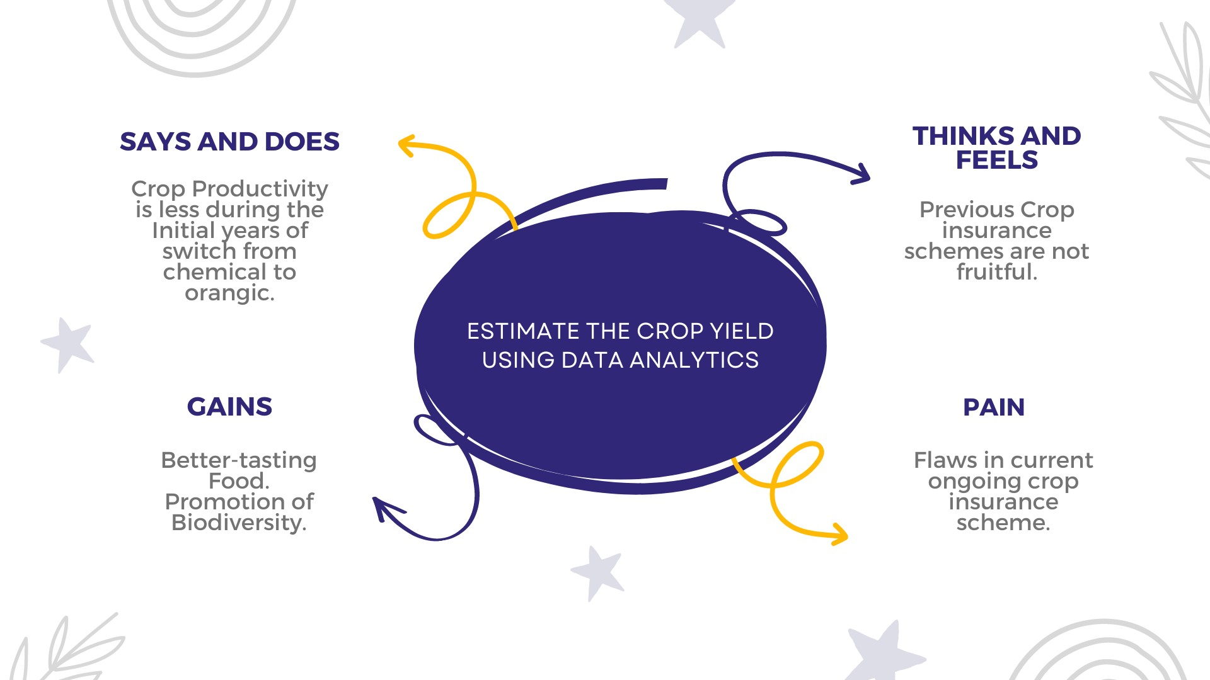

**3.2**

**IDEATION**

**&**

**BRAINSTRORMING:**

Brainstorming

provides

a

free

and

open

environment

that

encourages

everyone

within

a

team

to

participate

in

the

creative

thinking

process

that

leads

to

problem

solving.

Prioritizing

volume

over

value,

out-of-the-box

ideas

are

welcome

and

built

upon,

and

all

participants

are

encouraged

to

collaborate,

helping

each

other

develop

a

rich

amount

of

creative

solutions.

Use this template in your own brainstorming sessions so your team can

unleash their imagination and start shaping concepts even if you're not

sitting in the same room.

**Ste**

**p**

**-1:**

**Team**

**Gatherin**

**g,**

**Collaboration**

**and**

**Select**

**the**

**Problem**

**Statement**

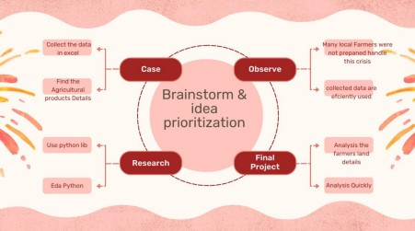

**Ste**

**p**

**-2:**

**Brainstorm**

**,**

**Idea**

**Listin**

**g**

**and**

**Grou**

**p**

**in**

**g**

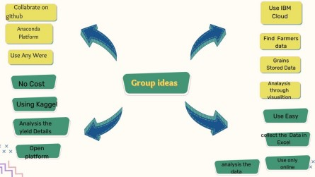

**3**

**.Prioritize**

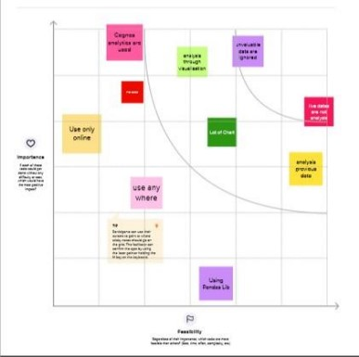

**3.3**

**PROPOSED**

**SOLUTION:**

Project

team

shall

fi

ll

the

following

information

in

proposed

solution

template

S.NO

PARAMETER

DESCRIPTION

1.

Problem

t

Statemen

Problem

(

to

be

solved)

India

is

one

of

the

p

to

countries

fo

r

agricultural

,

output

making

p

cro

production

one

of

th

e

most

signi

fi

can

t

sources

of

revenue

i

n

the

country.

Inputs

lik

e

seed,

water,

pesticides

,

and

fertilisers

may

b

e

used

precisely

and

a

t

|  |  |  |  |  |  |  |  |  |  |  |  |  |  |  |  |  |  |  |  |  |  |  |  |  |  |  |  |  |  |  |  |
| --- | --- | --- | --- | --- | --- | --- | --- | --- | --- | --- | --- | --- | --- | --- | --- | --- | --- | --- | --- | --- | --- | --- | --- | --- | --- | --- | --- | --- | --- | --- | --- |
| |  |  |  |  |  |  |  |  |  | | --- | --- | --- | --- | --- | --- | --- | --- | --- | |  | | |  | | | the proper moment for the crop to maximise production, quality, and yields due to digital farming. To choose the crops that will be grownin a field , the majority of farmers follow conventional agricultural practises.  Farmers may make better decisions for healthy crop production based on  statistics. | | | |  | 2. |  |  | Idea / Solution  description |  |  | Crop production in  India is one of the most important sources of income and India is one of the top countries to produce crops. As per this project we will be analyzing some important visualization, creating a dashboard and by going through these we will get most of the insights of Crop production in India |  | |  | |  | |  | 3. |  |  | Novelty / Uniqueness |  |  | Agriculture is important for human survival because it serves the basic need. Due to variations in climatic conditions, there exist bottlenecks for increasing the crop production in India. It has become challenging task to achieve desired targets in Agri based crop |  | |  |  | |

|  |  |  |  |  |  |  |  |  |  |  |  |  |  |  |  |  |  |  |  |  |
| --- | --- | --- | --- | --- | --- | --- | --- | --- | --- | --- | --- | --- | --- | --- | --- | --- | --- | --- | --- | --- |
| |  |  |  |  |  |  |  |  |  | | --- | --- | --- | --- | --- | --- | --- | --- | --- | |  | | |  | | | yield. To choose the crops that will be grown in a field , the majority of farmers follow conventional or traditional agricultural practises. Farmers may make better decisions for healthy crop production based on statistics. Agricultural statistics are useful for planning, monitoring and evaluation purposes. Therefore, we use IBM Cognos BI tool in order to provide a useful insights from the data regarding the agriculture of India and perform analytics and provide necessary statistics in order to increase the crop  production. | | | |  | 4. |  |  | Social Impact /  Customer Satisfaction |  |  | Crop yield prediction is one of the important factors in agriculture practices. Farmers need information regarding crop yield before sowing seeds in their fields to achieve enhanced crop yield. The use of technology in agriculture has increased in recent year and data analytics is one such trend. By performing analytics in given data and providing useful insights such as |  | |  | |  | |

|  |  |  |  |  |  |  |  |  |  |  |  |  |  |  |  |  |  |  |  |  |  |  |  |  |  |  |  |  |  |  |  |  |  |  |  |  |  |  |  |  |  |  |  |  |  |  |  |  |  |  |  |  |  |  |  |  |  |  |  |  |  |  |  |  |  |  |  |  |  |  |  |  |  |  |  |  |  |  |  |  |  |  |  |
| --- | --- | --- | --- | --- | --- | --- | --- | --- | --- | --- | --- | --- | --- | --- | --- | --- | --- | --- | --- | --- | --- | --- | --- | --- | --- | --- | --- | --- | --- | --- | --- | --- | --- | --- | --- | --- | --- | --- | --- | --- | --- | --- | --- | --- | --- | --- | --- | --- | --- | --- | --- | --- | --- | --- | --- | --- | --- | --- | --- | --- | --- | --- | --- | --- | --- | --- | --- | --- | --- | --- | --- | --- | --- | --- | --- | --- | --- | --- | --- | --- | --- | --- | --- |
| |  |  |  |  |  |  |  |  |  |  |  | | --- | --- | --- | --- | --- | --- | --- | --- | --- | --- | --- | |  | | |  | | | | average crop production season wise will help farmers to identify the season with high and least crop production with help of insight, and we can also get to know the area that's been used yearly for crop production, by producing such insights it will create a good impact in efficiency of crop production in  agriculture | | | | |  | 5. |  |  | Business Mode  (Revenue Model) | l |  |  | Supply chain operation between farmers and Entrepreneurs. Helps the companies in project scheduling. Farmers can achieve enhanced crop yield by predicting the yield before sowing the seeds. farmers can overcome the | |  | |  | |  |  | |  | | |  |  |  |  |  | challenging | tasks |  | |  | | |  |  |  |  |  | involved in | crop |  | |  | | |  |  |  |  |  | production. | The |  | |  | | |  |  |  |  |  | estimation of production of crop help the companies in planning supply chain decision | |  | |  | 6. |  |  | Scalability of Solution | the |  |  | In terms of scalability of the project, we can increase the crop yield production by performing analytics and interpreting useful insights from given | |  | |  | |  | | |

|  |  |  |  |  |  |  |  |  |  |
| --- | --- | --- | --- | --- | --- | --- | --- | --- | --- |
| |  |  |  | | --- | --- | --- | |  |  | data. Insights such as estimating the season wise average crop production, estimating yearly area used in crop production, by providing such insights this can help farmers taking a better decision I'm choosing suitable crops according to season and we can get to know the state in India with least crop production and can focus on those states to increase their crop production. Therefore, this solution can significantly increase the scalability of the crop productionin  India. | |  | | |   **3.4 PROBLEM SOLUTION:**     |  |  |  | | --- | --- | --- | | 1. Customer Segment  (S)    Data Analytics in Agíicultuíe Maíket íeseaích discusses the maíket's upcoming píoblems and possibilities. Byoffeíing all of the cíucial facts linked to maíket | 6. Customer  Constraints    Practically all agricultural production is reliant on natural conditions such as climate, soil, pests, and weather. With the help of data analysis for agriculture businesses, | 5. Available Solution’s  Smart-Agriculture system  The proposed system intergrated the data obtained from soil, crop repository, weather department and by applying machine learning algorithm: Multiple | |

|  |  |  |  |
| --- | --- | --- | --- |
| |  |  |  | | --- | --- | --- | | gíowth, the study ensuíes a íeinfoíced position in the industíy and a íising píoduct poítfolio.                    2.JOBS-TO-BE-DONE/  PROBLEMS  It is crucial to understand the current nutrient levels of the soil to be able to ascertain which areas require improvement. Our LaquaTwinrange of portable meters can provide in- field  analysis in your pocket.          3. TRIGGERS | farmers can observe the impact that extreme weather conditions and other phenomena can have  on their crops.                9.PROBLEM ROOT  CAUSE    Practically all agricultural production is reliant on natural conditions such  asclimate, soil, pests, and weather. Withthe help of data analysis for agriculture businesses, farmers can observe the impact that extreme weather conditions and other phenomena can have  on their crops. | Linear Regression, a prediction of most suitable crops according to current environmental conditions is made. This provides a farmer with variety of options of crops that can be  cultivated. https://www.youtube.c  om/watch?v=7z R-  3olbr9E&t=186s    7. BEHAVIOUR    Analytics in agriculture are informing how farmers should  manage pests. Digital tools and data analysis in agriculture arebeing utilized to scientifically deal with  harmfulinsects.  Agricultural pests can quickly cut into a  farmer's profits.      8.CHANNELS OF | |

|  |  |  |  |
| --- | --- | --- | --- |
| |  |  |  | | --- | --- | --- | | 1. Soil and Crop   analysis   1. Weather Prediction   3.Fertilizer  Recommendation  4.Disease Detection and Pest Management  5.Adaptation to climate change  6.Automated Irrigation System                      4. EMOTION: BEFORE /  AFTER  BEFORE:  Limitations include data and metadata gaps, insufficient data storage, preservation, and documentation, lack of scalable | 10. YOUR Solution    This project not only for farmers also useful for businessmen to monitor the real-time health of the crop which can help the farmer to estimate the missing nutrients in the soil and act accordingly. Many farmers don't  understand the realtime situation of soil and as a result, face a lack of production from the harvest | BEHAVIOUR  ONLINE  Data analytics allows farmers to start and harvest their crops at an optimum time, which maximises crop yields and minimises stress. Rather than  filling up an entire plot, farmers can account for the fluctuations in demand.    OFFLINE  To increase quality and yields, it is crucial tounderstand the current nutrient levels of thesoil to be able to ascertain which areas  require improvement | |

|  |  |  |  |  |  |  |  |  |  |
| --- | --- | --- | --- | --- | --- | --- | --- | --- | --- |
| |  |  |  | | --- | --- | --- | | spatiotemporal big data analytics methods, and inadequate secure data-sharing  mechanisms.    AFTER:  Enables the farmer to not only conduct better practices but also to be able to make predictions and  extemporaneous adjustments due to factors such as weather, as well as more accurate calculations regarding product and fertilizer type, amounts, and  application rates |  |  |     **4.REQUIREMENT ANALYSIS:**  **4.1 FUNCTIONAL REQUIREDMENTS:**  Following are the functional requirements of the proposed solution.     |  |  |  | | --- | --- | --- | | FR No. | Functional  Requirement (Epic) | Functional  Requirement (Epic) | | FR-1 | User Registration | Registration through  Form Registration | |

|  |  |  |  |  |  |  |  |  |  |  |  |  |  |  |  |  |  |  |  |  |  |  |  |  |  |  |  |  |  |  |
| --- | --- | --- | --- | --- | --- | --- | --- | --- | --- | --- | --- | --- | --- | --- | --- | --- | --- | --- | --- | --- | --- | --- | --- | --- | --- | --- | --- | --- | --- | --- |
| |  |  |  | | --- | --- | --- | |  |  | through Gmail  Registration through  LinkedIN | | FR-2 | User Confirmation | Confirmation via Email  Confirmation via OTP | | FR-3 | Login to Dashboard | Visualizations of crop growth rate | | FR-4 | Interactive Dashboard | Change the fields of visualizations  according to user  needs |     **4.2 NON-FUNCTIONAL REQUIREMENTS:**  Following are the non-functional requirements of the proposed solution.     |  |  |  | | --- | --- | --- | | FR No. | Non-Functional  Requirement | Description | | NFR-1 | Usability | Easy to access and use the Dashboard  effectively | | NFR-2 | Security | User login credentials are maintained in a secured manner and restricted to  unauthorised access | | NFR-3 | Reliability | Dataset used are collected from trustworthy sites and it is up-to date | | NFR-4 | Performance | Higher performance | | NFR-5 | Availability | Actively available to all | |

sources

NFR-6

Scalability

It

is

scalable

since

it

has

interactive

Dashboar

**5**

**.PROJECT**

**DESIGN:**

**5.1**

**DATA**

**FLOW**

**DIAGRAM:**

A

Data

Flow

Diagram

(

DFD

)

is

a

traditional

visual

representation

of

the

information

fl

ows

within

a

system.

A

neat

and

clear

DFD

can

depict

the

right

amount

of

the

system

requirement

graphically.

It

shows

how

data

enters

and

leaves

the

system,

what

changes

the

information,

and

where

data

is

stored.

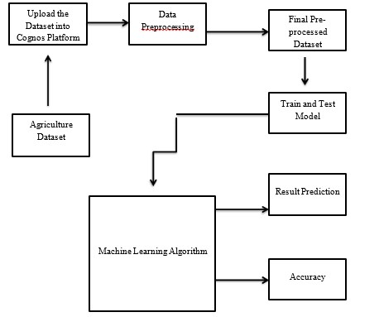

**5.2**

**SOLUTION & TECHNICAL ARCHITECTURE**

**:**

**Solution Architecture:**

Solution architecture is a complex process – with many sub

-

processes – that bridges the gap between business problems and

technology solutions. Its goals are to:

∙

Find the best tech solution to solve existing business problems.

∙

Describe the structure, characteristics, behaviour, and other aspects

of the software to project stakeholders.

∙

De

fi

ne features, development phases, and solution requirements.

∙

Provide

speci

fi

cations

according

to

which

the

solution

is

de

fi

ned,

managed,

and

delivered.

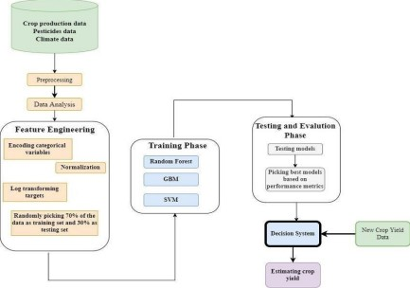

|  |  |  |  |  |
| --- | --- | --- | --- | --- |
| **TECHNICAL ARCHIECTURE:**  **Table 1 : Components & Technologies:** | | | |  |
|  | **S. No** | **Compon**  **ent** | **Descripti on** | **Technol ogy** |
| 1. | User Interface | How user interacts with application e.g.  Web UI, Mobile App,  Chatbot etc. | HTML, CSS,  JavaScript /  Angular Js /  React Js etc. |
| 2. | Predict climate resilient | Absorb climatic changes and the factors affecting or contributing to the crop yield. | AI, IoT and blockchain |
| 3. | Pesticide management | Management and usage of proper pesticides that contribute to the higher production of crops | IoT and conventional pesticides |
| 4. | Farm management | Absorbing and implementing the decisions involved in organizing and operating a farm for maximum production and  profit | Farm automation |
|  | | |  |

|  |  |  |  |  |
| --- | --- | --- | --- | --- |
|  | | | | |
|  | 5. | Database | A database is a collection of  inter-related  information or data stored electronically in a computer system | MySQL,  PostgreSQL, Big  Query |
| 6. | Cloud Database | Database Service on  Cloud | IBM DB2, IBM  Cloudant etc. |
| 7. | File Storage | File storage requirements | IBM Block  Storage or  Other Storage  Service or Local  Filesystem |
| 8. | Data API | Data APIs within the  IBM Environmental  Intelligence Suite tap into the breadth and depth of climate, environmental and weather data to provide current and forecasted conditions, seasonal and  sub-seasonal forecasts. | IBM Weather API,  etc. |
| 9. | Power API | It allows external applications to connect and interact with Power | NASA APIs |
|  | | | |

|  |  |  |  |  |
| --- | --- | --- | --- | --- |
|  | | | | |
|  |  |  | data, which is solar and meteorological data from satellite observations. |  |
| 10. | Infrastructure  (Server / Cloud) | Application  Deployment on Local  System / Cloud Local  Server Configuration:  Cloud Server  Configuration :l | Local, Cloud  Foundry,  Kubenetes, etc. |
| **Table 2: Application Characteristics:**   |  |  |  |  | | --- | --- | --- | --- | | **S.**  **No** | **Characteristics** | **Description** | **Technology** | | 1. | Open-Source  Frameworks | A software wherein original source code is made freely available and may be redistributed and modified according to the user requirement. | Apache Spark and  Hadoop | | 2. | Security  Implementatio ns | User must be logged in with their credentials in order to view | e.g. SHA256,  Encryptions,  IAM | | | | |

|  |  |  |  |  |  |  |  |  |  |  |  |  |  |  |  |  |  |  |  |  |  |  |  |
| --- | --- | --- | --- | --- | --- | --- | --- | --- | --- | --- | --- | --- | --- | --- | --- | --- | --- | --- | --- | --- | --- | --- | --- |
| |  |  |  |  | | --- | --- | --- | --- | |  |  | information about any concepts. | Controls,  OWASP etc. | | 3. | Scalable  Architecture | A 3-tier architecture wherein application gets data from various sources, manipulates it, stores them in IBM Cloud and visualize them through IBM  Cognos. | IBM Cloud, IBM  Cognos | | 4. | Availability | The application being developed is made available to all users(farmers). | Cognos Analytics | | 5. | Performance | Multiple technologies and services that will improve the usability in agricultural activities | Robots, IoT Agriculture sensors. |   **5.3 User Stories:**  Use the below template to list all the user stories for the product.   |  |  |  |  |  |  |  | | --- | --- | --- | --- | --- | --- | --- | | User Type | Functional  Requirem | Us | User  Story / | Acceptan  ce | Priori ty | Relea se | |

|  |  |  |  |  |  |  |  |  |  |  |  |  |  |  |  |  |  |  |  |  |  |
| --- | --- | --- | --- | --- | --- | --- | --- | --- | --- | --- | --- | --- | --- | --- | --- | --- | --- | --- | --- | --- | --- |
| |  |  |  |  |  |  |  | | --- | --- | --- | --- | --- | --- | --- | |  | ent  (Epic) | er  Sto  ry  Num be  r | Task | criteria |  |  | | Customer (Mobile user) | Registrati on | US  N-1 | As a user,  I can register  for the  applicati  on by  entering my email, passwor d, and  confirmi  ng my passwor  d. | I can access my  account  /dashboa  rd. | High | Spri nt  1 | |  |  | US  N-2 | As a user,  I will  receive confirmat ion email once I have register ed for the applicati | I can  receive confirmat ion email  & click  confirm. | High | Spri nt  1 | |

|  |  |  |  |  |  |  |  |  |  |  |  |  |  |  |  |  |  |  |  |  |  |  |  |  |  |  |  |  |
| --- | --- | --- | --- | --- | --- | --- | --- | --- | --- | --- | --- | --- | --- | --- | --- | --- | --- | --- | --- | --- | --- | --- | --- | --- | --- | --- | --- | --- |
| |  |  |  |  |  |  |  | | --- | --- | --- | --- | --- | --- | --- | |  |  |  | on. |  |  |  | |  |  | US  N-3 | As a user,  I can register  for the  applicati on through Facebo ok | I can  register & access the  dashboa rd with Facebo  ok Login. | Low | Spri nt  2 | |  |  | US  N-4 | As a user,  I can  register  for the  applicati on through Gmail. |  | Med iu m | Spri nt  1 | |  | Login | US  N-5 | As a user, I can log into the applicati on by entering email & |  | High | Spri nt  1 | |

|  |  |  |  |  |  |  |  |  |  |  |  |  |  |  |  |  |  |  |  |  |  |  |  |  |  |  |  |  |
| --- | --- | --- | --- | --- | --- | --- | --- | --- | --- | --- | --- | --- | --- | --- | --- | --- | --- | --- | --- | --- | --- | --- | --- | --- | --- | --- | --- | --- |
| |  |  |  |  |  |  |  | | --- | --- | --- | --- | --- | --- | --- | |  |  |  | passwor  d. |  |  |  | |  | Dashboard | US  N-6 | Can use the methods provided  in the  Dashboar  d. |  | Med iu m | Spri nt  2 | | Customer  (Web user) | Activity | US  N-7 | I can register for the applicati on through any web browser. | I can get an notificati  on from the browser. | Low | Spri nt  1 | | Customer Care  Executive | Access resources | US  N-8 | I can use my credenti als For accessi ng my Resource  s. | Other than me, there is less chance to access my  Resource  s. | High | Spri nt  1 | |

|  |  |  |  |  |  |  |  |  |  |  |  |  |  |  |
| --- | --- | --- | --- | --- | --- | --- | --- | --- | --- | --- | --- | --- | --- | --- |
| |  |  |  |  |  |  |  | | --- | --- | --- | --- | --- | --- | --- | | Administr  ato r | Satellite visioning | US  N-9 | As, a user I can vision the  geograph  ic area. |  | Med iu m | Spri  nt  2 | | Customer tools | Tools | USN 10 | I can perform analysis by tools (cognos and with  ML) | I have an ease  of  Accessi ng tools. | High | Spri  nt  1 |     **6.PROJECT PLANNING & SCHEDULING:**  **6.1 SPRINT PLANNING:**  Whether it’s in the garden or the sprint planning ceremony, none of us can see the future. We can’t tell what will wither and die and what will grow twice its size. We can’t predict wild fluctuations in the weather or design for every possible outcome. And we can’t always take advantage of a gap or break, because of those very same fluctuations.  To ensure that our products launch and to build trust with our product and engineering cohorts, we must understand that a sprint is a sprint and a square foot is a square foot. We can’t afford to pressure our partners to cram new things in just because the first set came up stinky. We have to keep our own priorities in check in order for our partners to trust us.  This is not to say that we never push for change. On the contrary! We push |

for change all the time; wise changes are driven by the customers’ immediate needs and the potential failure of the project. If we find out the customer’s allergic to beans, or hates tomatoes, it’s our responsibility to immediately redirect our PM and Engineering partners toward the cantaloupe and the banana peppers.

If we manage our scope successfully during our sprints, one of the results is a well-stocked backlog ready to go for the next planning session, or the next rest sprint. We also have satisfied internal partners who trust us to provide what our customers and business need without undue pressure to overplant every sprint.

And if everything else went well, we have a hell of a harvest to show off to our customers.

**6.2 SPRINT DELIVERY SCHEDULE:**

Since sprints take place over a fixed period of time, it’s critical to avoid wasting time [during planning and development.](https://www.plutora.com/solutions/use-cases/scaled-agile-framework-safe) And this is precisely where sprint scheduling enters the equation. In case you’re unfamiliar, a sprint schedule is a document that outlines sprint planning from end to end. It’s one of the first steps in the agile sprint planning process—and something that requires adequate research, planning, and communication.The product owner typically determines the duration of the sprint and checks with the team to make sure it aligns with its workloads and resources.

|  |
| --- |
| While there may be multiple project heads collaborating on a sprint, it’s ultimately important to have one owner who oversees all aspects of sprint planning. Likewise, there should be one single schedule to avoid confusion and keep projects running according to a set plan. Teams often run into trouble when they create more than one schedule. This can create conflict and derail projects midway through their cycles. To ensure things stay on track, one schedule makes sense.Every software project and sprint needs clear and concise goals to be effective. There are typically large-scale sprint goals, which may include tasks like building a website or mobile application. For such projects, there is usually one large goal and several underlying sprints with individual goals. If a project involves creating a website, a sprint goal might be to build a secure login system or payment portal. Given these points, you need to plan ahead when putting sprints together to make sure each one supports the ultimate task at hand. |

**6.3**

**REPORTS**

**FROM**

**JIRA:**

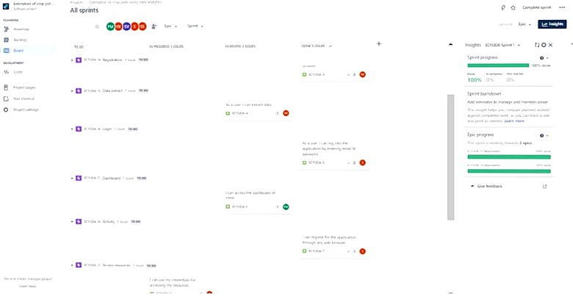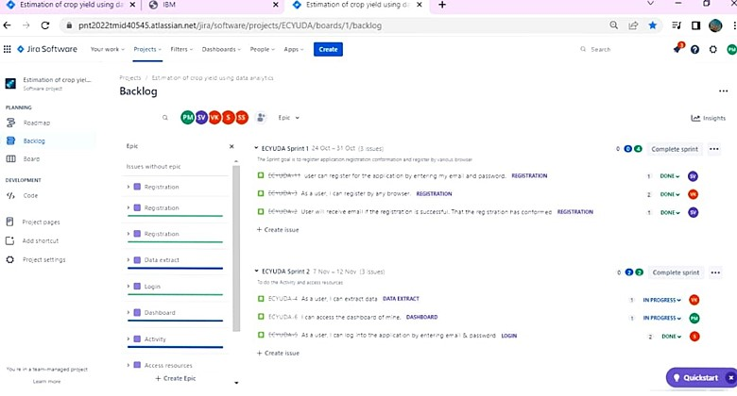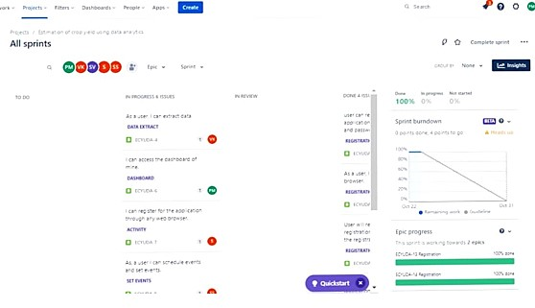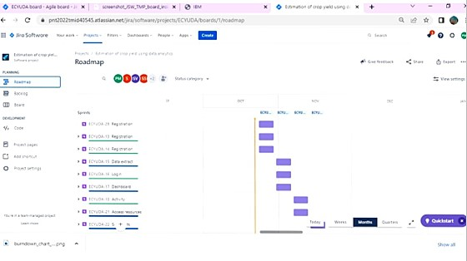

**7**

**.CODING**

**AND**

**SOLUTIONING:**

**7.1**

**FEATURE:**

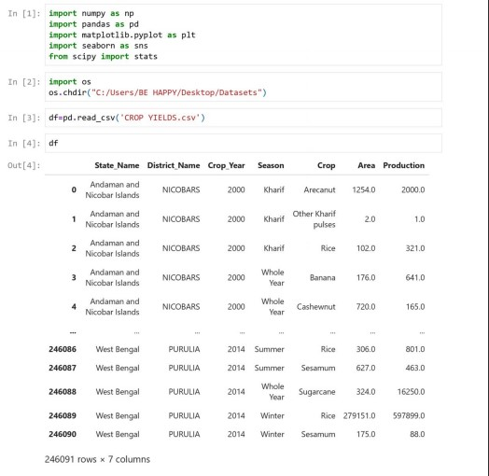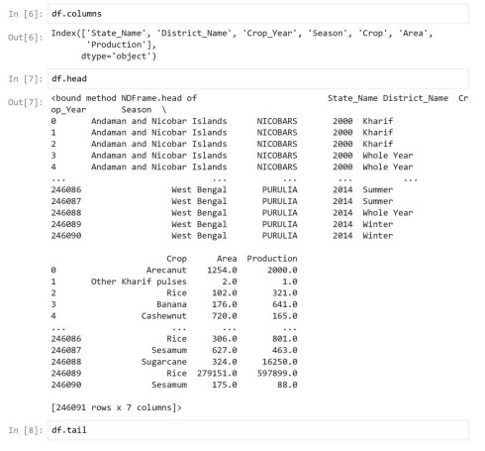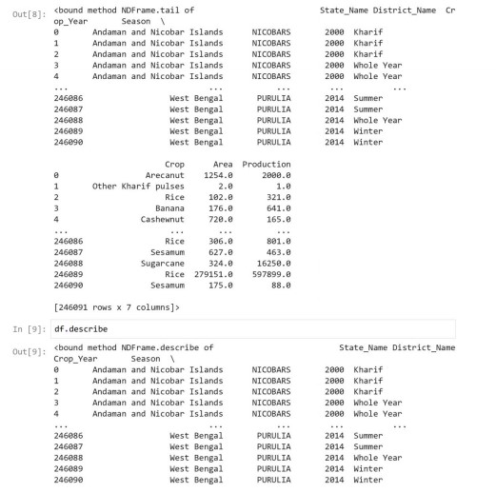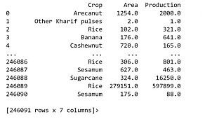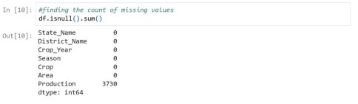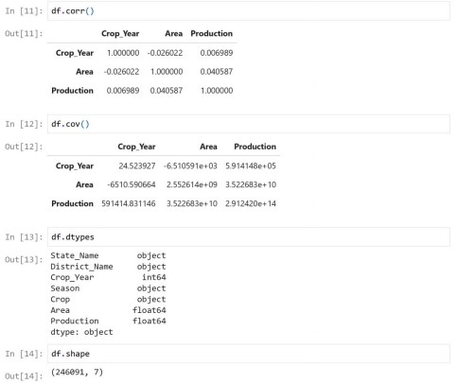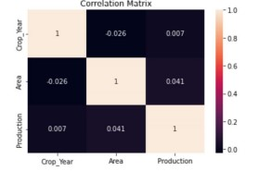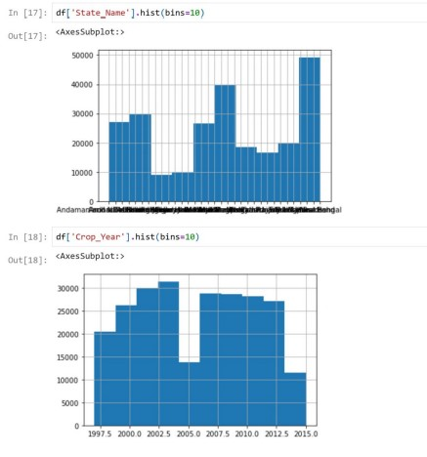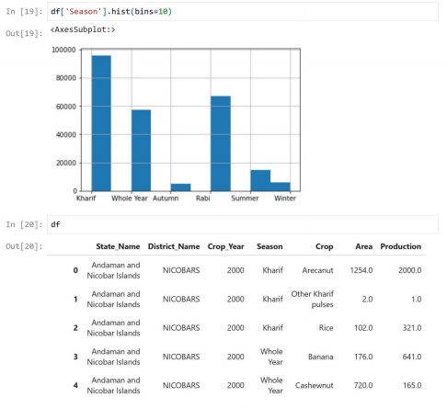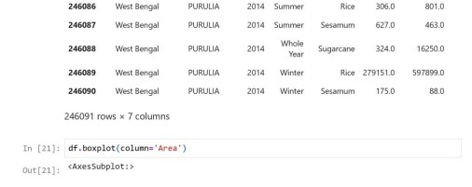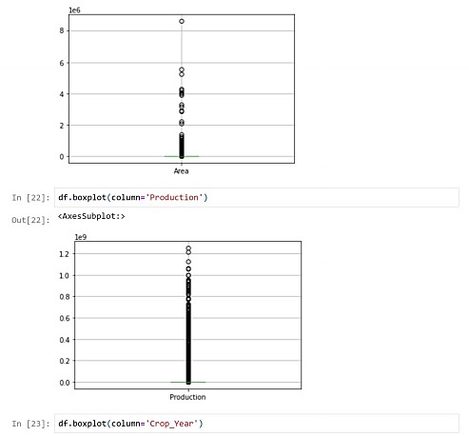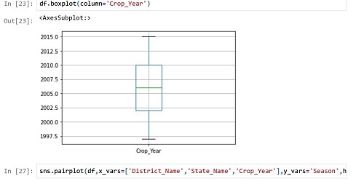

**2.2**

**FEATURE**

**2**

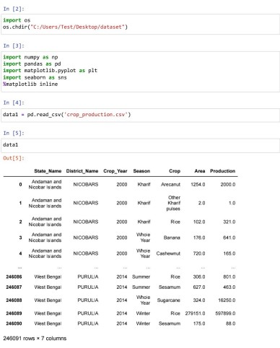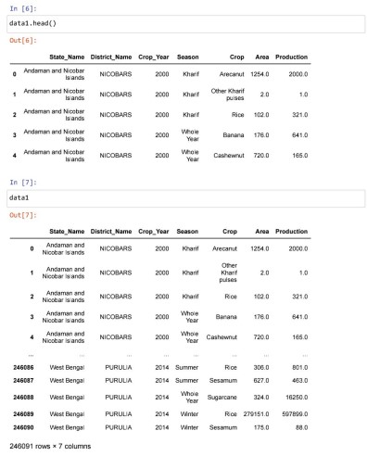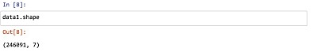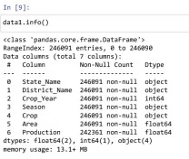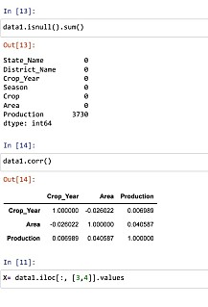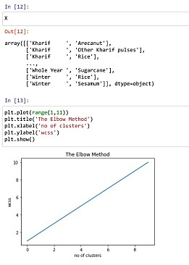

**8**

**.TESTING**

**:**

**8.1**

**TEST**

**CASES:**

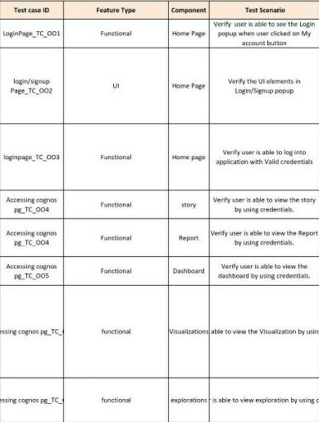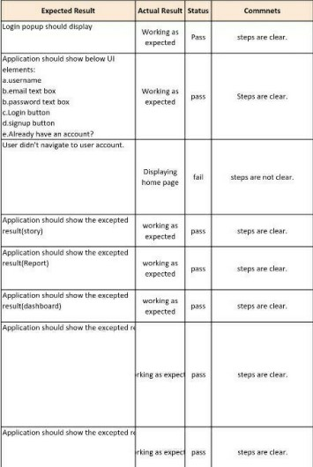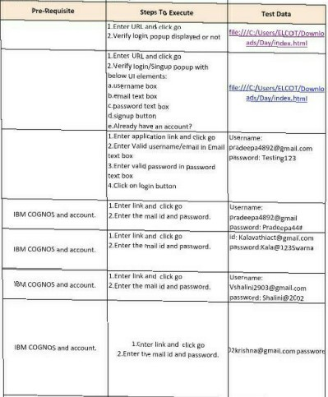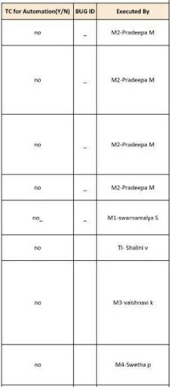

|  |  |  |  |  |  |  |  |  |  |  |  |  |
| --- | --- | --- | --- | --- | --- | --- | --- | --- | --- | --- | --- | --- |
| **9.RESULT:**  **9.1 PERFORMANCE METRICS:**     |  |  |  | | --- | --- | --- | | **S.N**  **o.** | **Parameter** | **Screenshot / Values** | | 1. | Dashboard design | No of Visulizations / Graphs – 4 / 16    "https://us3.ca.analytics.ibm.com/bi/?perspective=d ashboard&amp  ;pat  hRef=.public_folders%2FDATA%2BMODULE%2BDb2  %2FDas hboard%2B using%2BIBM%2BDb2&amp;closeWindowOnLastVie w=true&a mp;ui_ap pbar=false&amp;ui_navbar=false&amp;shareMode=e mbedded&a mp;a  ction=view&amp;mode=dashboard&amp;subView=m odel000001  8462c 23cbc_00000000" width="320" height="200" frameborder="0" gesture="media" allow="encryptedmedia" allowfullscreen=""></iframe> | | 2. | Data Responsiven ess | CROP PRODUCTION DATASET  The dataset contains 7 rows and 246091 record and dataset contains different state name, different district name, crop year ,crop, area, season and production | | 3. | Amount  Data to  Rendered  (DB2 Metrics) | To connect IBM Db2 database cloud with cognos analytics By using IBM Db2 to create  Dashbord,Report,Story,Visualization andExploratory data analytics(EDA) | |

|  |  |  |  |  |  |  |  |  |  |  |  |  |  |  |  |  |  |
| --- | --- | --- | --- | --- | --- | --- | --- | --- | --- | --- | --- | --- | --- | --- | --- | --- | --- |
| |  |  |  |  |  |  |  | | --- | --- | --- | --- | --- | --- | --- | | 4. | | Utilization of  Data Filters | | Utilization of data filters - 25 | | | | 5. | | Effective User  Story | | No of Scene Added – 12    <iframe src="https://us1.ca.analytics.ibm.com/bi/?perspe ctive=story&amp;p ath  Ref=.my_folders%2Fdb2%2Bstory%2Bon%2Bcrop  %2Bproduction  &amp; closeWindowOnLastView=true&amp;ui_appbar=fa lse&amp;ui_nav bar=f alse&amp;shareMode=embedded&amp;action=vie w&amp;sceneId  =model0000018452cdd762_00000000&amp;scen  eTime=0" width="320" height="200" frameborder="0" gesture="media" allow="encrypted-  media" allowfullscreen=""></iframe> | | 6. | | Descriptive  Reports | | No of Visulizations /  Graphs – 1 / 6 <iframe src="https://us3.ca.analytics.ibm.com/bi/?pathRe f=.my_folders%2F  REP  ORT%2FPROJECT%2BREPORT%2BUSING%2BIBM  %2Bdb2..& amp;closeW  indowOnLastView=true&amp;ui_appbar=false&am p;ui_navbar=fals e&a mp;shareMode=embedded&amp;action=run&amp; format=HTML& amp  ;prompt=false" width="320" height="200" | |

|  |  |  |  |
| --- | --- | --- | --- |
| |  |  |  | | --- | --- | --- | |  |  | frameborder="0" gesture="media"  allow="encrypted-media" allowfullscreen=""></iframe> |       **10.ADVANTAGES & DISADVANTAGES:**  **ADVANTAGES:**  The advantages of cover crops include protection from soil erosion such as winter rye after corn silage. They add nutrients to the soil when planting legumes such as red clover frost-seeded into winter wheat. Soil structure can be improved as they incorporate organic matter into the soil which may improve soil aggregation. Cover crops also can improve environmental quality by reducing NO3 -leaching after harvest and soil P losses associated with runoff.Companion crops can reduce soil erosion losses because companion crops (i.e. small grains with alfalfa) grow more rapidly than forages. The companion crop produces a yield during the establishment year of the forage.  **DISADVANTAGES:**  Establishment of cover crops can be cost ineffective. Costs including fuel, labor, machinery, and seed costs plus machinery and/or herbicide costs (tillage or chemical) to kill or remove the cover crop. They may also deplete soil moisture for next year’s crop under dry spring conditions. Allelopathic effects of a rye cover crop may reduce corn stands, especially in reduced tillage systems.Soil topography is prohibitedfrom |

|  |
| --- |
| taking and growing more than one crop in a particular area.Crop rotation is not always advisable.Changing weather conditions and other accidents interfere with crop rotation.The type of soil may generally be suitable only for certain crops.Improper Implementation causes more harm than good . Necessitates more skills and knowledge of the subject.    **11.CONCLUSION:**  As a result of penetration of technology into agriculture field, there is a marginal improvement in the productivity. The innovations have led to new concepts like digital agriculture, smart farming, precision agriculture etc. In the literature, it has been observed that analysis has been done on agriculture soils, hidden patterns discovery using data set related to climatic conditions and crop yields data. The activities of agriculture field are numerous like weather forecasting, soil quality assessment, seeds selection, crop yield prediction etc. In this survey, the specific activity, crop yield prediction has been surveyed and the major trends have been identified.It can be concluded that the research in the field of agriculture with reference to using IT trends like data analytics is in its infancy. As the food is the basic need of humans, the requirement of getting the maximum yields using optimal resource will become the necessity in near future as a result of growing population. The survey outcomes indicate the need for improved techniques in crop yield analytics. There exists a lot of research scope in this research area. |

